Payroll- Access Reports to Argos

EmplSTATS – to compile employee data monthly to report to US Dept. of Labor

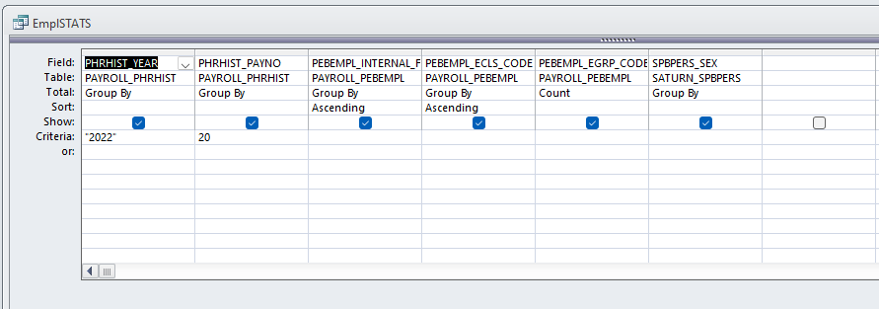
This is the Design View. I change the PAYNO, save and then run.

Web time status2 - used to compile a list each pay period of supervisors and their employees whose timesheets were overridden as well as memos for them to sign with approvals.
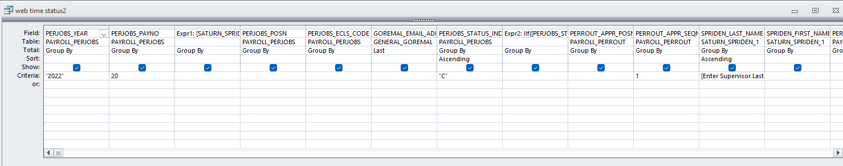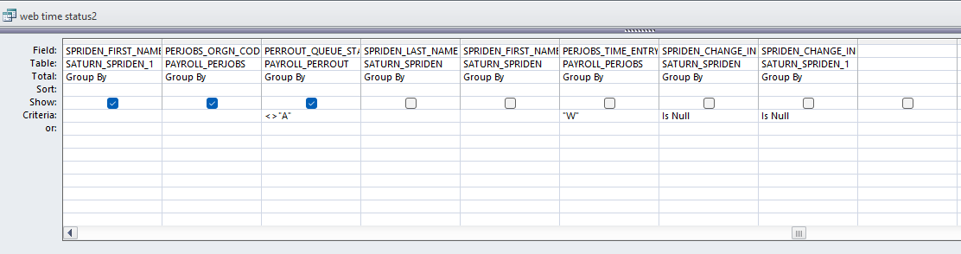
This I do in two steps. In Design View, I update the pay # and save. Then I open up Design View again and highlight and remove: [Enter Supervisor Last Name] At this point I click RUN. DO NOT SAVE! This compiles the list of all supervisors and their employees whose timesheets were overridden. After I print the list, I close without saving so that [Enter Supervisor Last Name] stays in that field.
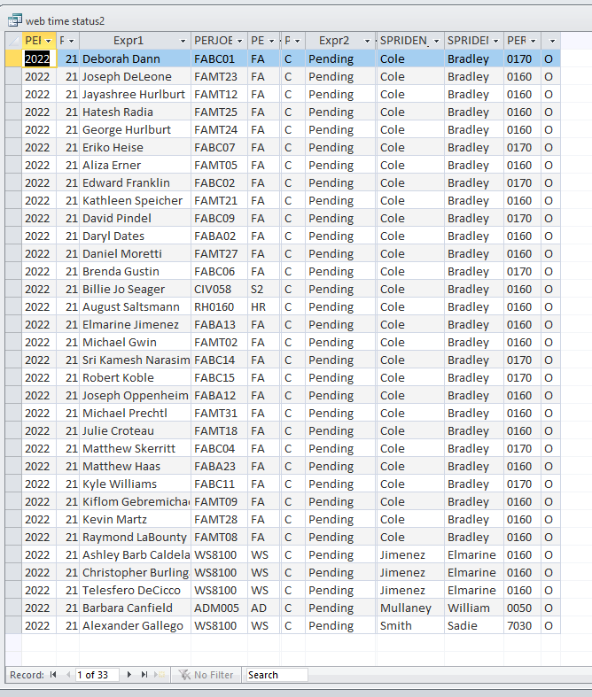
Once I update this bi-weekly list and print, then I go to:
WEB TIME – Design View - I type in and change the pay period and save. Close.
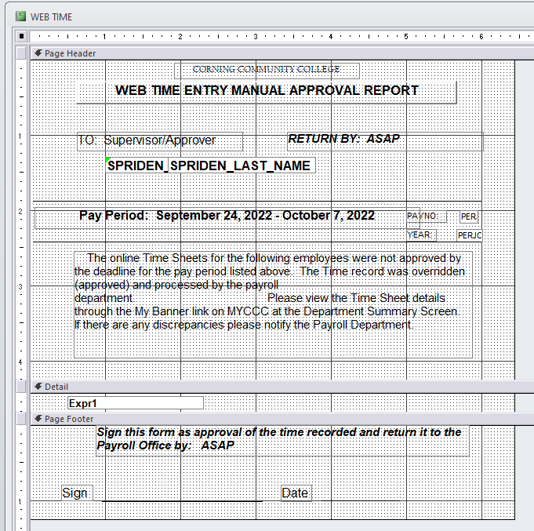

To create individual Supervisor Approval Memos, I double click on WEB TIME to get this:
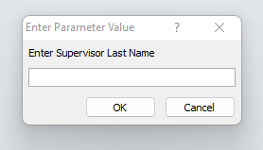
Then one at a time, I type in each supervisor’s name and OK. This creates a memo for each and pulls in only their employees whose timesheets weren’t approved for that pay period. It also populates the PAYNO and YEAR
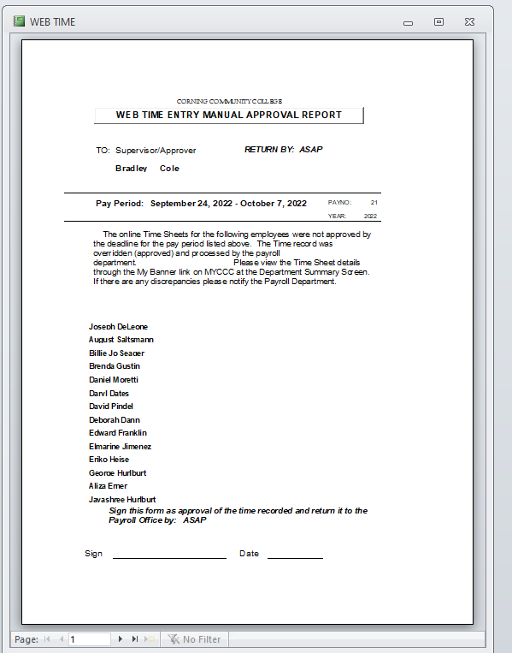

In SecureHR in Access, I can pull reports using Menus. I don’t know how this is created, but this is what I see.
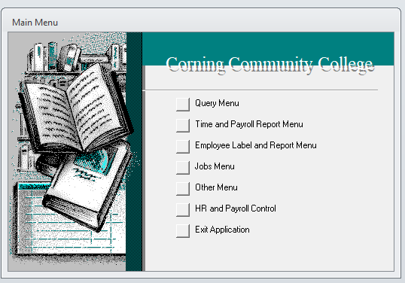
For running an Earn Code Error report every two weeks:
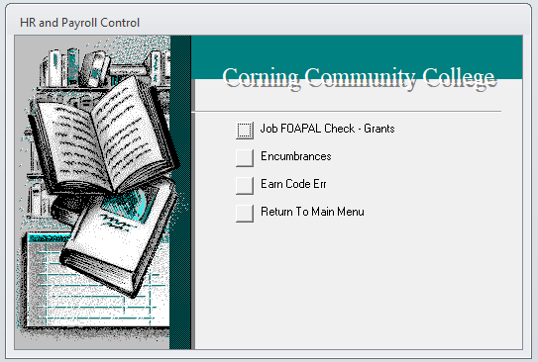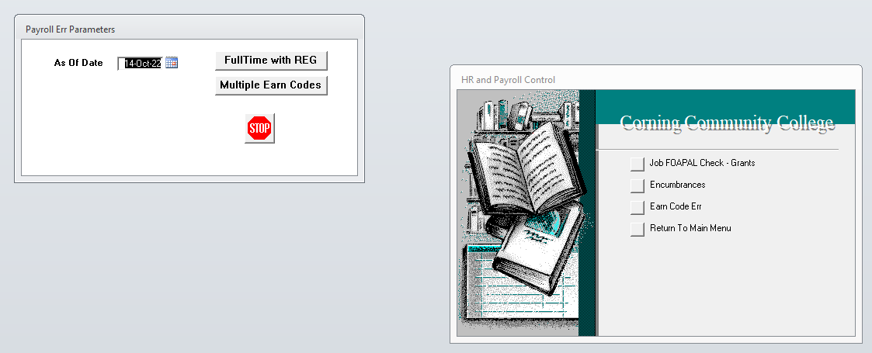

I enter specific dates for both FullTime with REG. Here is an example of what is produced:
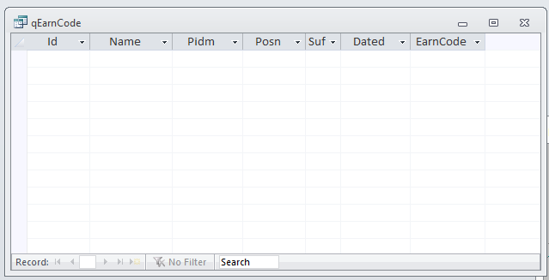
and Multiple Earn Codes which produces:
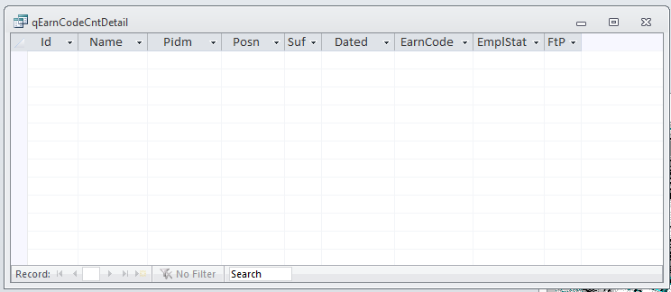
Errors will show up if there are any.

Human Resources uses this menu to run a “download” which compiles any new employee information that has been entered within the date range entered.
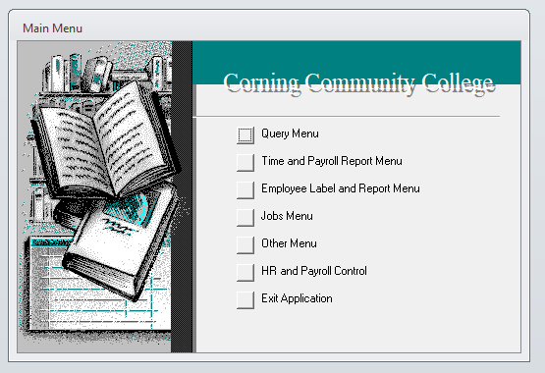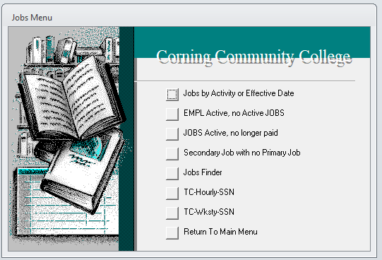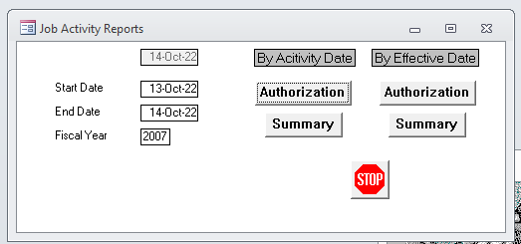

After the dates are put in, then they click on Authorization to come up with this which provides me with up to date pay information. Here’s an example:
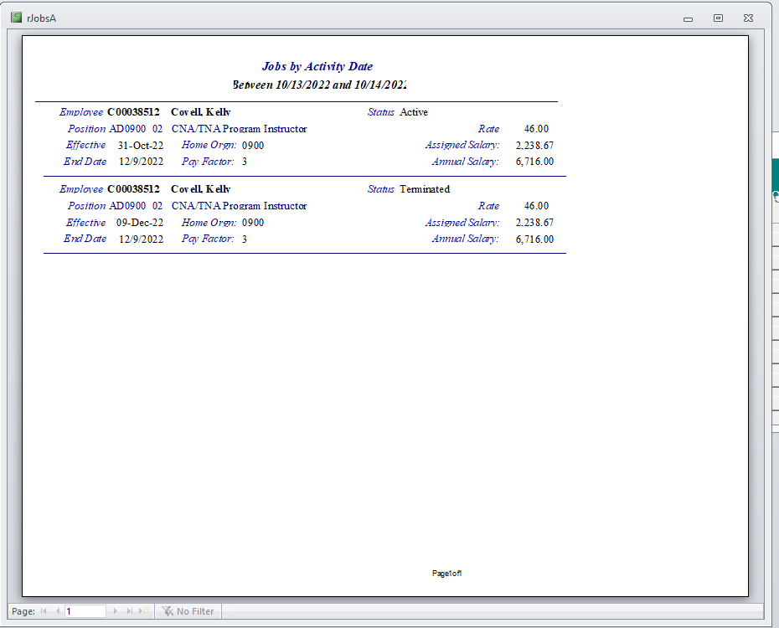
Depending on the week, these can be multiple pages. These reports are the only thing given to the Payroll Dept. to notify us of specific current changes. Super important!
If possible, I would like to add more fields to this report such as Supervisor and their Position number, and FOAP (Fund, Orgn, Acct, Program).

I also use this menu to create paper timecards for our Physical Plant Union employees. Their department number is 6600. This does not create timecards for Calvin, Dave, Karen, or Diana which is good. They do their timesheets online. These are the steps:
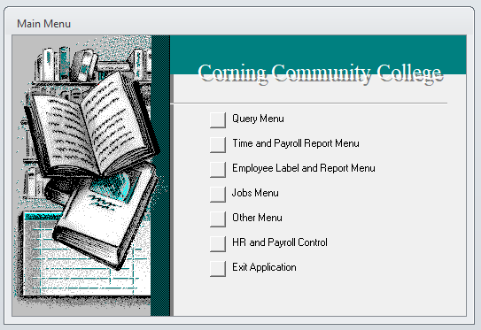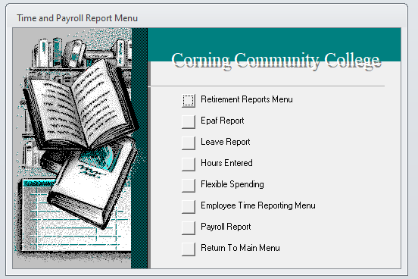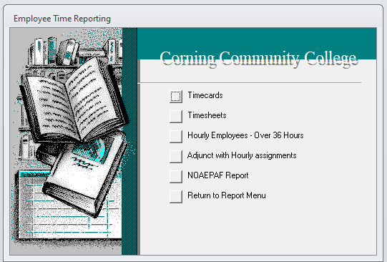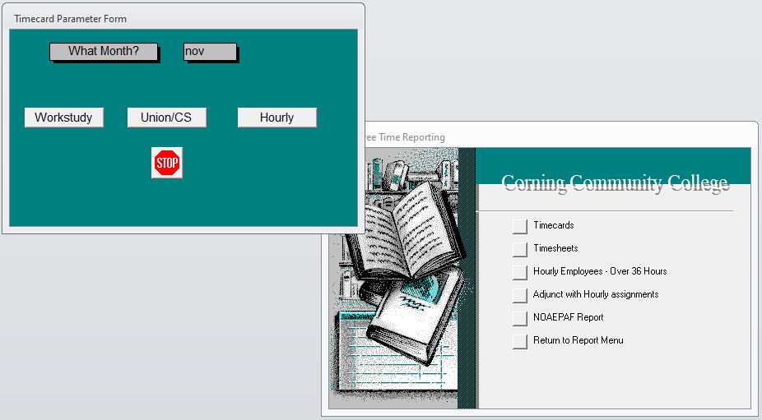

I enter the month and click either Union/CS or Hourly. (Workstudy timecards are no longer printed)

This is the result that I can send to the printer where I’ve loaded blank timecard templates. The information prints in the appropriate areas.
